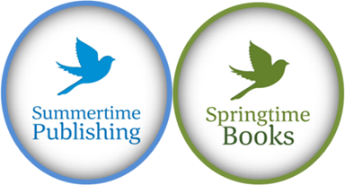
Application

The Lindsay de Feliz Award for new writers of expat memoir

BEFORE YOU START, BE SURE YOU HAVE THE FOLLOWING DOCUMENTS READY. . .

- A table of contents in Word
- Three sample chapters in 12 point Times Roman font, single-spaced

Thank you for applying for the Lindsay de Feliz bursary for new writers of expat memoir. Lindsay, author of What About Your Saucepans and Life After My Saucepans, was brutally murdered near her home in the Dominican Republic in December 2019. This award has been created in her memory.
Lindsay first approached us in 2011 to ask if we might be interested in publishing her memoir. After giving up her home, marriage and well-paid job in the financial sector, she moved to the Dominican Republic in 2008 to be a diving instructor. She soon fell in love with both the island and a younger man called Danilo, eventually marrying him and becoming a willing stepmother to his sons. Then Danilo decided he wanted to be mayor and things became very sticky indeed. There was no doubt that she had a great story to tell, however, though she had the makings of a manuscript she knew nothing about plot and pace and character, about story arcs and painting a scene. Together, and with the help of editor Jane Dean and publisher Jack Scott, we brought her story to print in 2013.

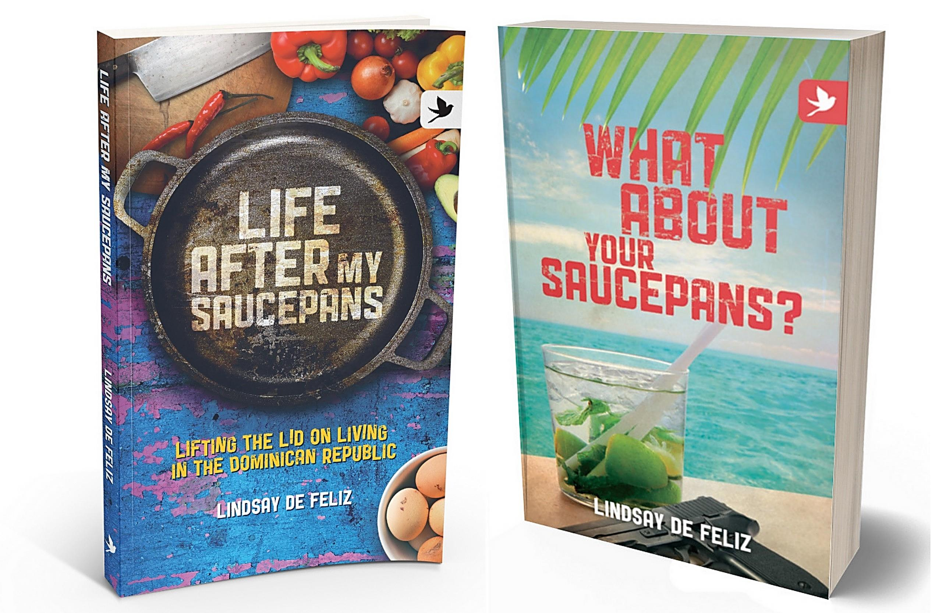

Lindsay went on to become a bestselling author and, in 2017, we published the sequel.
Lack of published work is no reason not to apply for this award. If you have a story to tell and know that you have what it takes to share it with the world, then be like Lindsay and go for it!
To apply, please complete this document and submit it, along with three chapters and a table of contents to publisher@summertimepublishing.com.
The awards close on 31 July 2o2o. A winner will be announced on 30th September 2020. The successful book will be published in 2021.
Jack and I wish you the very best of luck.
Best wishes

Jo Parfitt Jack Scott
Managing Editor, Summertime Business Manager Summertime Publishing and Springtime Books Publishing and Springtime Books

Getting focused
If you can describe your book succinctly this will prove it has focus. Every author needs to be able to describe their book in a single sentence. Keep this in mind as you write below:
What, in a general sense, is your book about? (maximum 200 words).

What would you write on the back cover of the book to draw readers in? This is called the blurb. Please write 150 words

To check your book has focus, you need to describe it in one sentence. Please do so here.

The Author
What makes you the perfect person to write this book?

Can you write in a readable, accessible way? How do you know? Have you been published before? If so, tell us where and include any links if possible.

Your book will need a biography of you. What will you mention in yours?

Marketing Potential
People search online using keywords. What would be the title and subtitle for your book? Do you have some keywords?

What makes your book different? What is its ‘WOW’ factor?

Do you know there is a market for books like yours. What books have you read that you think are similar to yours? Name them here.

What do you want the reader to think, do or feel after they have read your book?

A book should inspire, inform, support or entertain. Which of these four will your book do for the reader?

Social Media
Do you have an online presence? What social media do you use regularly and what for?

Savvy authors find people who are interested in their book long before the book is published. You want to whet their appetite for your book and make them desperate for it to be published. How do you think you will be able to spread the word about your book?

Planning and Writing
Memoirs are usually 55,000 to 90,000 words long. How long do you plan yours to be?

Have you thought about content for each of your chapters and mind mapped or otherwise drafted a plan for them? Explain the general story arc or plot that your book will follow. If this question confuses you fill in the blanks to:

I started out______________________________________
And then ________________________________________
And then ________________________________________
But then ________________________________________
And then ________________________________________
I ended up _______________________________________

Write your own version of this below:

Marketing
Who do you think will buy your book? What is your market? How big is it? How do you know?

Presuming you will also be trying to sell your book yourself, how are you intending to do this? Blog? Website? By speaking at events? Author signings? A virtual book tour? A book launch party? Will you produce a Book Trailer video? List your routes to market here:

Which editors of magazines or newspapers might be interested in your ‘story’ or the ‘story of your book’?

Do you know any famous or important people who could write a foreword to your book? Name them here:

Which famous or important people do you know who could write reviews of your book for the back cover?

What other ideas do you have for other books in the future that might complement this one?

Providing free articles is a great way to get free publicity for your book. What articles could you write and for which markets?

Where will you find people to whom you can send review copies of your book and who will then agree to post reviews on Goodreads, Amazon and their blogs? Can you name influential people you know already?
Now please save this document with the name LindsayDeFelizBursaryYOURNAME and submit along with your table of contents and three sample chapters, in Word, also named with LDFB and your name and send by 31 July to Jack and Jo and publisher@summertimepublishing.com

